WMEC 111 Assignment 3

Vladimir Petrovic MQ4592672

Marks Claimed:

* Outside Section (25%)
* Indoor Section (25%)
* Particle Effects (10%)
* Use of Multiple Different types of NavMesh Agents (10%)
* Direct Light sources beyond the directional light, reflection probes and surfaces, emissive materials (15%)
* A simple single-state animation (5%)

**Total Marks Claimed: 90%**

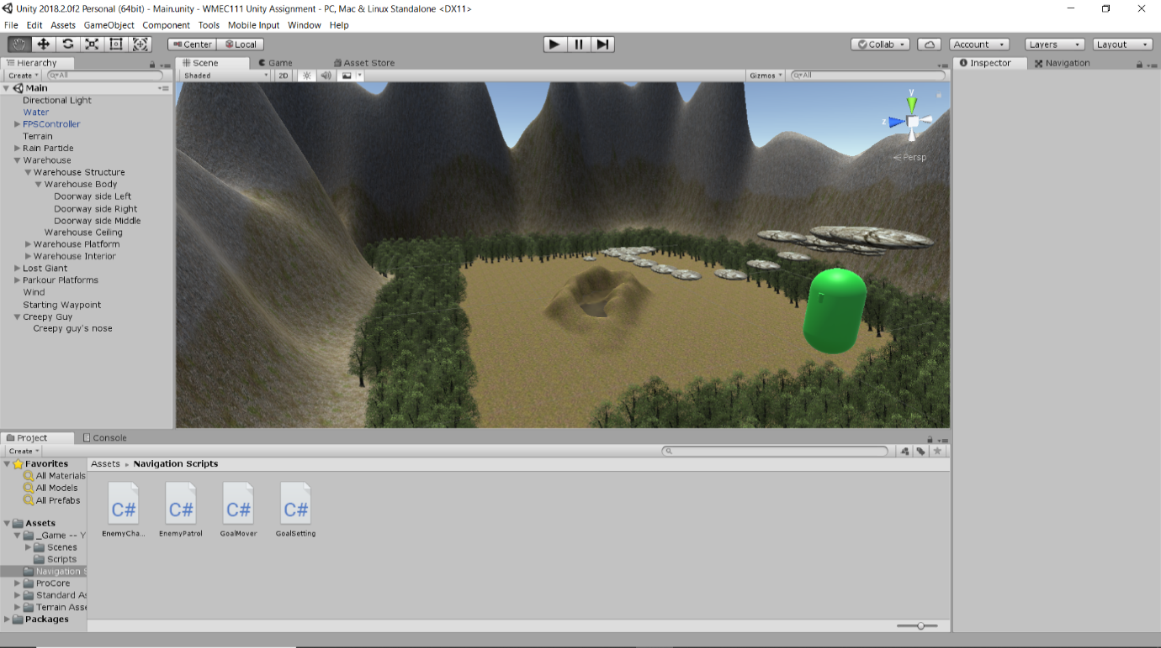The Terrain

I have chosen to use a grass meadows texture as my base while painting on a rocky grass and rock texture to my mountains. I also have painted a cliff rock texture to the mountain holding the warehouse. The platforms also have a rock texture to match this. This terrain also has trees and grass that leads the player to the starting platform in order to guide them. There is a wind effect added and a day night cycle using the animated directional light.

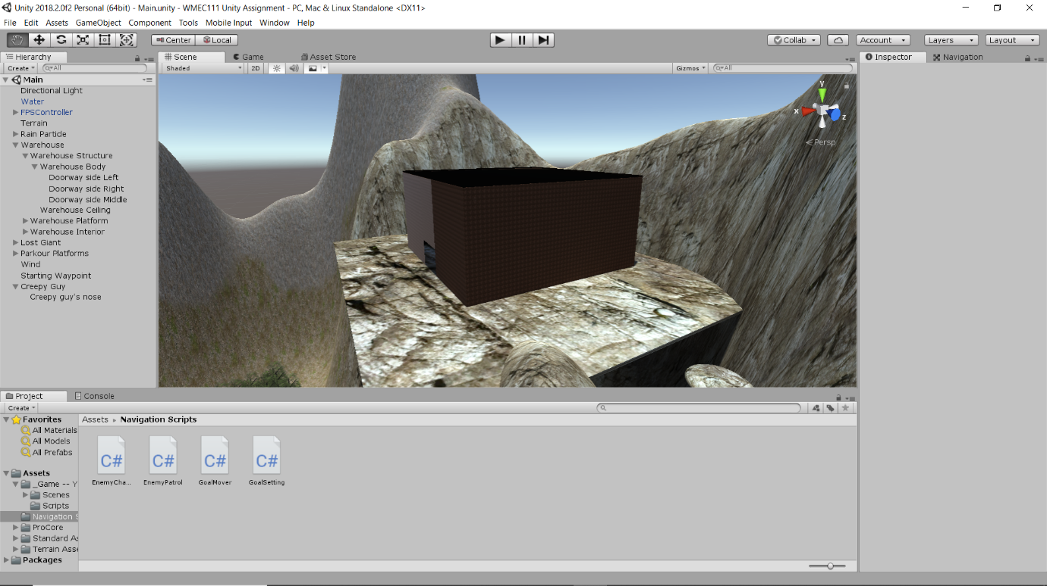The Warehouse

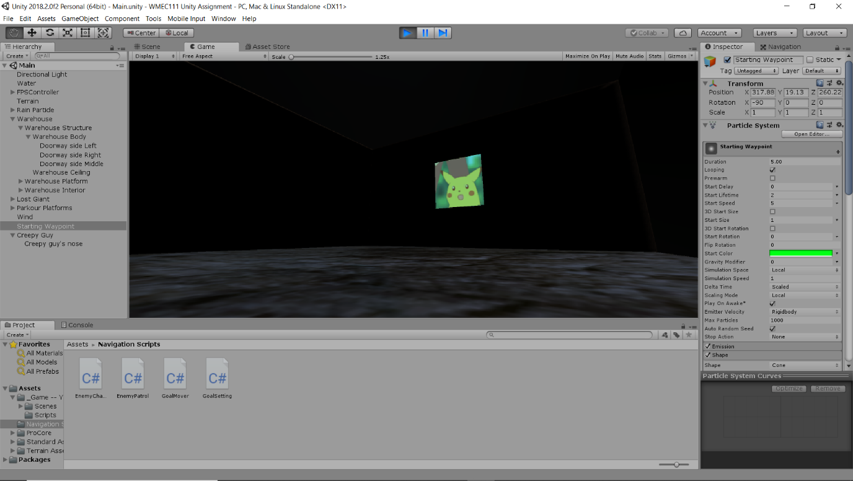The warehouse is held up by a rock textured platform supported by a pillar. The warehouse itself is made using probuilder and has a red rock texture applied to it. The interior has a quad with an emissive light while also depicting a surprised pikachu image. There is also a reflective sphere in the corner acting as a camera.

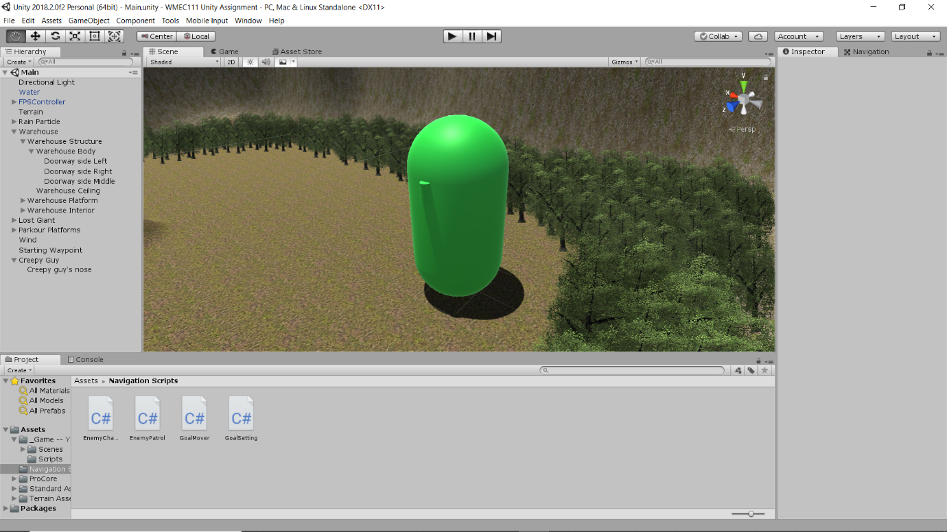The Lost Giant

The giant roams around the terrain using 4 points as guides. It is made using the base Unity objects (capsule and cylinder) and has a green texture applied.

The Creepy Guy

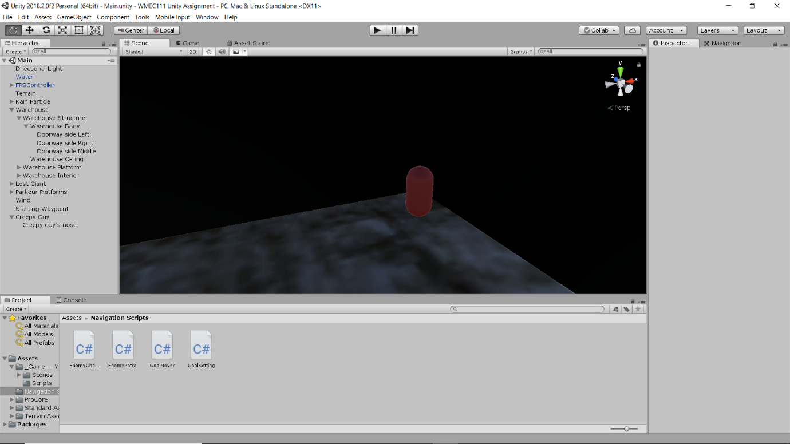The creepy guy chases the player once they enter the warehouse. He is made exactly like the giant however has dark red material applied.

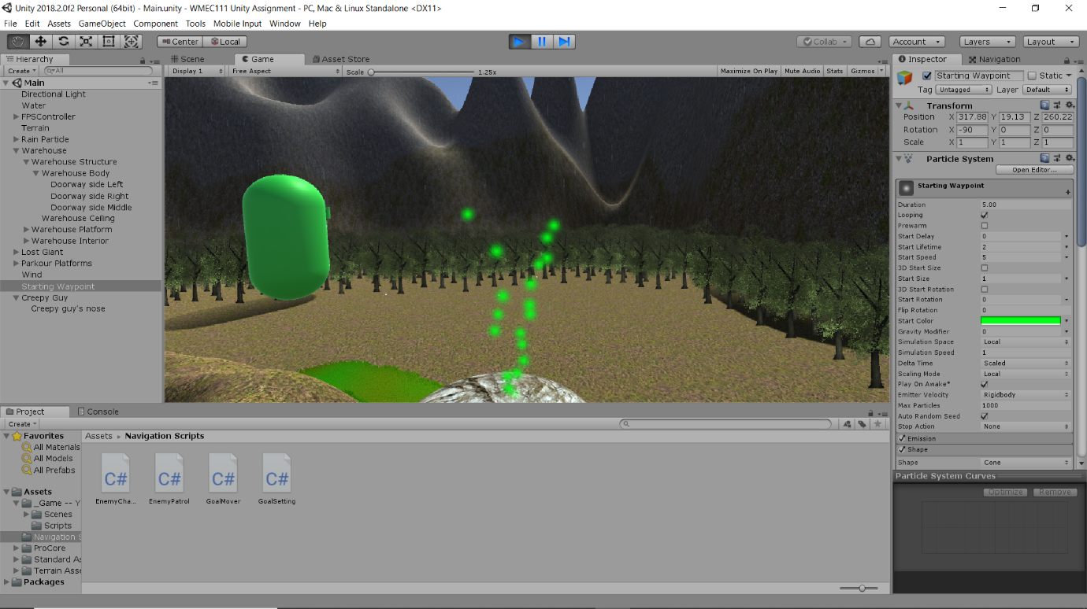The Particles

I added a green particle system as a waypoint and have also include rain particles.

Challenges and Changes

I originally was going to have a door mechanic, but it didn’t fit the theme for the warehouse. A challenge was trying to optimise the pathing of the giant however I am happy how it turned out.

Assets Used

* Standard Assets – Unity Technologies
* Navigation Scripts – Week 5 Lesson 4
* Probuilder 2x – Unity Technologies
* Surprised Pikachu image - <https://imgur.com/gallery/BU8YJ03>